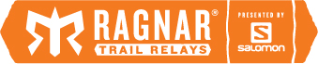
Award | Bib # | Name
Favorite Team Name | 265 | Running to know aVAIL
Best Team Costumes | TBD | TBD
Best Team Campsite | 163 | Train 4 Autism Team Then What
Overall Favorite Team | 111 | Fox in Trail Socks

Instagram Winners

TBD

